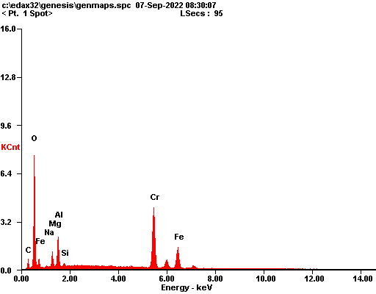

|  |  |  |
| --- | --- | --- |
| ***Element*** | ***Wt%*** | ***At%*** |
| ***CK*** | 04.35 | 11.67 |
| ***OK*** | 17.23 | 34.72 |
| ***NaK*** | 00.31 | 00.44 |
| ***MgK*** | 03.07 | 04.08 |
| ***AlK*** | 05.94 | 07.09 |
| ***SiK*** | 00.54 | 00.62 |
| ***CrK*** | 42.59 | 26.40 |
| ***FeK*** | 25.96 | 14.98 |
| ***Matrix*** | Correction | ZAF |

